Media release Davos Nordic 14th November 2019

Starting the new cross-country skiing season with an ace in the whole

The cross-country skiing season in Davos has officially opened on Saturday, 26th October 2019. Davos has done pioneering work on the four-kilometre-long snowfarming trail. Not only athletes from all over the world benefit from the snowfarming project, but also Davos Nordic benefits from the last year snow.

The starting signal for the new cross-country skiing season in Davos was given on the last weekend of October. The four-kilometre-long cross-country trail has long been an ace up the sleeve, for many more than just the Swiss cross-country skiers. National teams from France, Germany, Italy and a few more are taking the long way to Davos to train as early as possible on snow for an optimally preparation for the new World Cup season. All slots available in October for the elite runners are already booked.

The secret weapon for Davos Nordic
In addition to the attractive training opportunities offered by the Snowfarming trail, last year's artificial snow is an important factor for the Cross-Country World Cup in Davos, which is traditionally held early in the World Cup calendar. A large part of the Snowfarming trail is part of the cross-country World Cup slope. Due to the warm temperatures in the recent weeks, the October cross-country ski run has been subjected to an endurance test. Four weeks remain until Davos Nordic on 14th and 15th December. Although not much white gold has fallen from the sky yet, the organisers are confident that there will be enough snow in the Flüelatal for the World Cup weekend. With more than 40 years of experience, there will certainly be ways for a successful World Cup 2019.

With ticket prices support young talents
Always on the lookout for improvements, the Davos Nordic OK has given the event grounds a facelift. A better view of the big screen for the spectators in the finish area to name one of the different innovations. For the first time, the Dario Cologna Fun Parcours offers the opportunity to use rental equipment and go on a cross-country course free of charge. Everyone is welcome to try the first steps on cross-country skis. This year a ticket price of CHF 10.00 for the Davos Nordic finish area will be introduced. With little contribution spectators will be part of the cross-country skiing spectacle on the Bünda; children up to the age of 16 will of course continue to be free of charge. With the Davos Nordic Park and the Daehlie Kids event as well as the Dario Cologna Fun Parcours, Davos Nordic is consciously committed to young cross-country skiers, which is why CHF 2.00 per ticket sold is invested in projects to promote young talents.
Below the program:

Friday, 13th December 2019
18:15 Athletes presentation at the Christmas Market

Saturday 14th December 2019
11:30 Sprint Women & Men Prologue - free technique
14:00 Sprint Women & Men Finals
afterwards press conference school building Bünda
18:15 Athletes presentation at the Christmas Market

Sunday 15th December 2019
10:45 Single start women 10km free technique
12:30 19. Daehlie Kids Event
14:55 Single start men 15km free technique

Short Portrait Davos Nordic
Already for the 46th time the cross-country skiing world elite meets for the traditional cross-country skiing World Cup in Davos. Approximately 250 athletes from 30 nations will compete for valuable World Cup points. The attractive supporting programme and the spectators on site will create a breathtaking atmosphere in the stadium.

Short Portrait Snowfarming
Snowfarming is part of snow management in Davos. Since 2008 a 20,000 cubic metre heap of snow has been covered with sawdust in spring. This snow is used in autumn to prepare a four-kilometre-long cross-country ski trail. Covering the track will preserve about 70-80% of the snow volume. The procedure guarantees an early start to the cross—country season regardless of the temperatures in autumn.

Contact
Fabio Lechner
Media Davos Nordic, Davos Klosters
Talstrasse 41, CH-7270 Davos (Schweiz)
+41 81 415 21 18
fabio.lechner@davos.ch / davosnordic@davos.ch

Britta Wild
Head-Office Davos Nordic, Davos Klosters
Talstrasse 41, CH-7270 Davos (Schweiz)
Tel. +41 (0)81 415 21 56
britta.wild@davos.ch / davosnordic@davos.ch

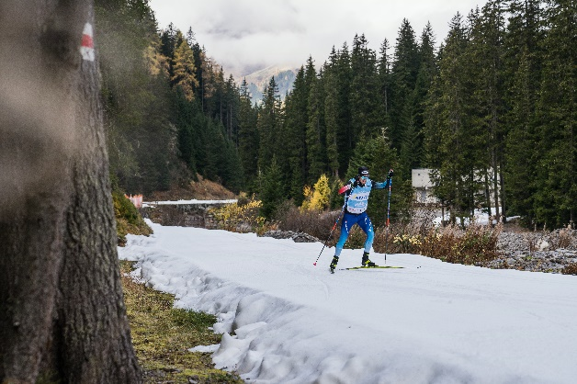
«Dario Cologna is preparing for a new world cup season in Davos.» (Foto Davos Klosters/Carmen Wenger)

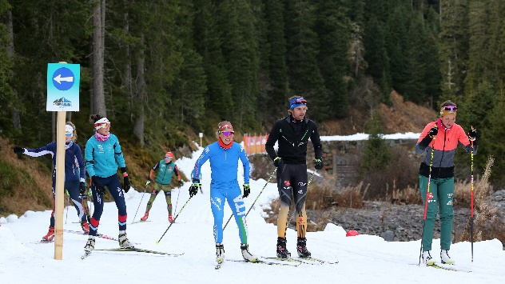
«A lot of different nationalities are training in Davos on the snowfarming track» (Foto Marcel Giger)

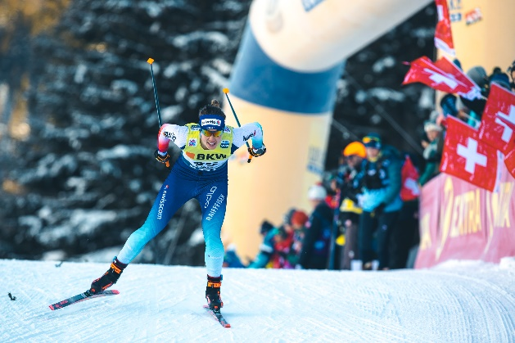
«The worldcup in Davos is always a big party for crosscountry skiing fans.» (Foto Marcel Hilger)

